**Lab_Day-2 ANP-C9180 (Operators)**

1. **Calculate the multiplication and sum of two numbers .**

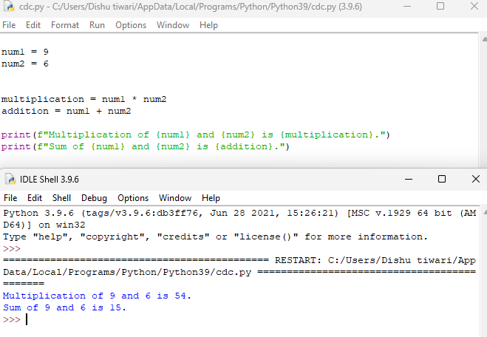

1. **Declare two variables and print that which variable is largest using ternary operators .**

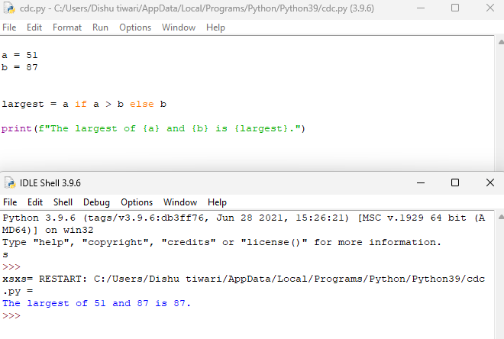

1. **Python program to convert the temperature in degree centigrade to Fahrenheit.**

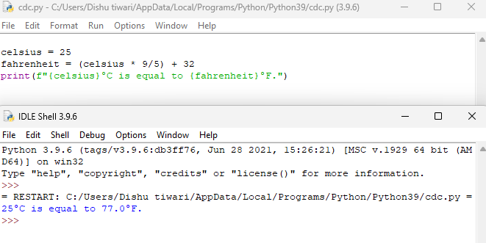

1. **Python program to find the area of a triangle whose sides are given.**

**To find the area of a triangle with given sides, use Heron's formula:**

